Project Charter: End-to-End Relational and Dimensional Modelling
Phase 1: Data Acquisition & Discovery
Dataset: Online Shop 2024 Dataset
Source data: https://www.kaggle.com/datasets/marthadimgba/online-shop-2024
Deliverable
The Online Shop 2024 dataset comes from an e-commerce platform and contains data about how the business operates. It has multiple related tables that store information about customers, products, orders, items in each order, and payments.
This dataset can help us understand:
- How customers buy products and their purchasing patterns
- Which products sell the most
- Trends in orders over time
- Payment activity and status
Other tables like shipping or supplier details are not included, so we can focus on the main business parts: customers, orders, products, order items, and payments.

Entities in Raw Dataset

1. Customers Table
This table holds the information about all the customers in the system.
It includes:
- customer_id
- first_name
- last_name
- address
- email
- phone_number

2. Orders Table
This table contains details of orders placed by customers.
It includes:
- order_id
- customer_id
- order_date
- total_price

3. Order_Items Table
This table stores information about the individual items within each order.
It includes:
- order_item_id
- order_id
- product_id
- quantity
- price_at_purchase

4. Products Table
This table contains information about all products available in the store.
It includes:
- product_id
- product_name
- category
- price
- supplier_id

5. Payments Table
This table records all payments transactions for orders
It includes:
- payment_id
- order_id
- payment_method
- amount
- transaction_status
Phase 2 : Relational Data Modeling (ERD)
Entities in the Model:
- Customers
- Orders
- Order_Items
- Products
- Payment
Primary Keys & Foreign Key:
- Customers
Primary Key: customer_id
Attributes: first_name, last_name, address, email, phone_number

- Orders
Primary Key: order_id
Foreign Key: customer_id
Attributes: order_date, total_price

- Order_Item
Primary Key: order_item_id
Foreign Key: order_id, product_id
Attributes: quantity, price_at_purchase

- Products
Primary Key: product_id
Attributes: product_name, category, price, supplier_id
(Note: supplier_id not needed for this model)

- Payments
Primary Key: payment_id
Foreign Key: order_id
Attributes: payment_method, amount, transaction_status

Relationship:
Relationship | Type
Customers → Orders | One to Many
Orders → Order_Items | One to Many
Products → Order_Items | One to Many
Orders → Payments | One to One

ER Diagram:
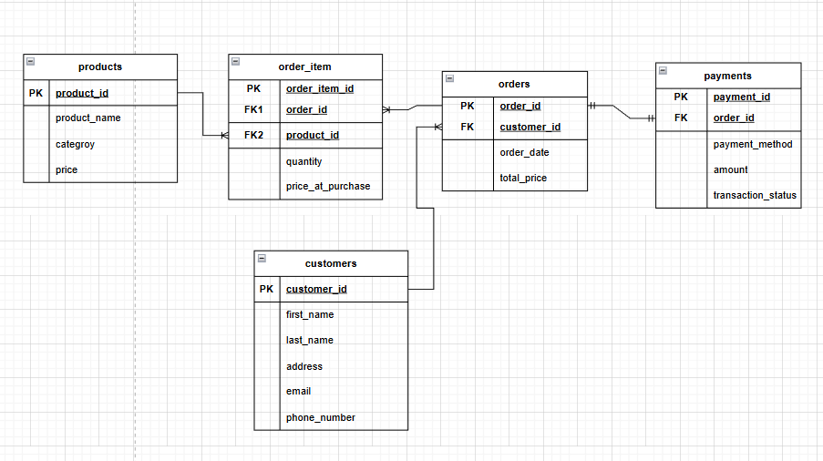

Phase 3 : Dimensional Modeling (Star Schema)
Fact Table : factSales
Grain of factSales : One row represents one product sold in one order on a specific date.
Column | Description
sales_key | Unique identifier for each sales record (fact row).
order_key | Degenerate dimension representing the order in which the product was sold.
customer_key | Links to dim_customer to identify who made the purchase
product_key | Links to dim_product to identify which product was sold.
date_key | Links to dim_date to identify when the sale happened.
payment_key | Links to dim_payment to identify how the order was paid.
quantity_sold | Number of units of the product sold (measure).
price_at_purchase | Price the customer actually paid per unit (measure).
actual_price | Original product price before discount (measure).
total_sales_amount | Total sale value (quantity × price paid) (measure).

Dimension Table:
- dimCustomer :
Column | Description
customer_key | Surrogate key that uniquely identifies each customer in the dimension table.
first_name | Customer’s first name.
last_name | Customer’s last name.
address | Customer’s residential or delivery address.
email | Customer’s email address.
phone_number | Customer’s contact phone number.

- dimProduct :
Column | Description
product_key | Surrogate key that uniquely identifies each product in the dimension table.
product_name | Name of the product.
product_category | Category or type of the product for grouping and analysis.

- dimDate :
Column | Description
date_key | Surrogate key that uniquely identifies each date in the dimension table.
full_date | Complete calendar date (YYYY-MM-DD).
day | Day of the month (1–31).
month | Month number (1–12).
year | Year of the date.
quarter | Fiscal or calendar quarter (1–4).
weekday | Day of the week (e.g., Monday, Tuesday).

- dimPayment :
Column | Description
payment_key | Surrogate key that uniquely identifies each payment transaction in the dimension table.
payment_method | Method used for the payment (e.g., Credit Card, Cash).
transaction_status | Status of the payment (e.g., Completed, Pending, Failed).

Star Schema Design :
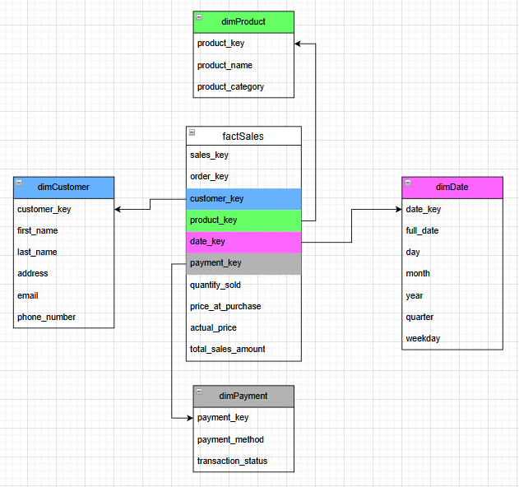
Phase 4: Database Implementation (DDL)
In this phase, the conceptual and logical data models were translated into a physical database using SQL Data Definition Language (DDL). Both the transactional schema and the dimensional star schema were implemented to support operational processing as well as analytical reporting.
Separate tables were created for entities such as customers, products, orders, and payments in the OLTP model, while fact and dimension tables (fact_sales, dim_customer, dim_product, dim_date, and dim_payment) were designed for the data warehouse. Appropriate data types including INTEGER, VARCHAR, NUMERIC, DATE, and TIMESTAMP were selected based on the nature and usage of each attribute.
Primary keys were defined to uniquely identify records, and foreign keys were used to establish relationships between fact and dimension tables, ensuring referential integrity. Additional constraints such as NOT NULL, UNIQUE, and CHECK were applied to maintain data consistency and prevent invalid entries.
This phase ensures that the database structure is robust, optimized, and suitable for efficient querying and analytical processing. The complete DDL scripts are included in the project documentation.
Phase 5 : Business Logic & Analytics (DML/DQL):
The final phase focuses on deriving meaningful insights from the data using SQL Data Manipulation and Query Language (DML/DQL). Data was populated into the dimensional model using ETL logic, after which analytical queries were developed on top of the fact and dimension tables.
Advanced SQL features such as joins, aggregations, grouping, filtering, and window functions were used to answer practical business questions. These queries support analysis of sales performance, customer behavior, product effectiveness, and regional trends.
This phase demonstrates how raw transactional data can be transformed into actionable insights, enabling data-driven decision-making and effective business analysis.

Business Metric | Business Question | Explanation
High-Value Regions by Average Sales | Which regions have higher average sales than a given threshold? | This metric shows regions where customers spend more money on average per order. These areas are important because they represent strong markets where the business can increase marketing efforts or open more services.
Unsold Products | Which products have never been sold? | This metric finds products that do not appear in any sales records. It helps the business identify items that are not popular or may need better marketing, discounts, or removal from inventory.
Top Customers by Total Spend | Who are the top 10 customers who spend the most money? | This metric identifies the customers who contribute the highest revenue. By knowing the top-spending customers, the business can focus on loyalty programs, special discounts, and personalized offers to keep these valuable customers.
Monthly Revenue by Product Category | How much revenue is generated each month from different product categories? | This metric shows how sales change every month for each product category. It helps the business understand which products sell more during certain months and which categories perform best overall. This information is useful for planning promotions and managing inventory.
The respective script is also attached with the documentation.

